Lab2

Z5382484-LinXing Jia

Exercise 3:

Q1.

The status code is 200 and the phrase is “OK” .

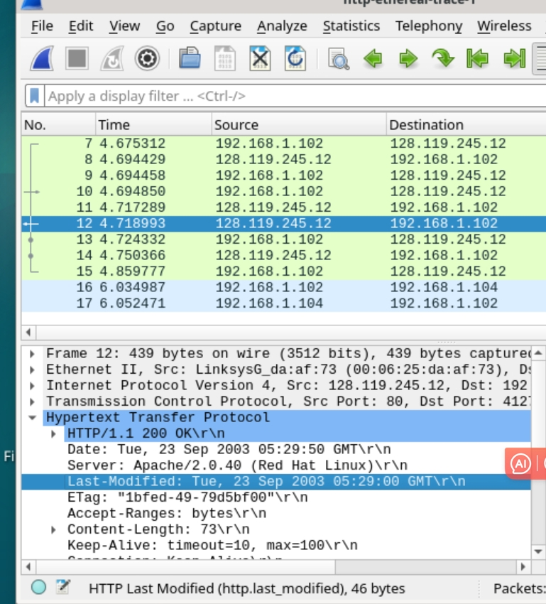

Q2.

The HTML file that the browser is retrieving was last modified on Tue, 23 Sep 2003 05:29:00 GMT. This can be seen in the "Last-Modified" header on the graph.

Yes, this response also contains the DATE Header, the Date header indicates the time when the response was generated, while the Last-Modified header indicates the time when the HTML file was last modified.

Q3.

The connection header in the response clearly indicates "keep-alive", which represents a persistent connection. After the client sends a request, it can continue to use the same TCP connection to send the next request without closing the connection.

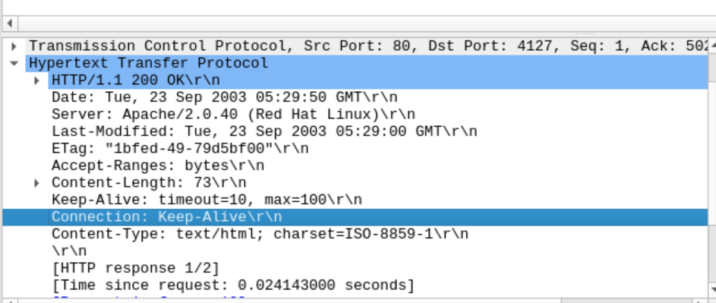

Q4.

According to content-length header, the length of the content being returned to the client is 73 bytes.

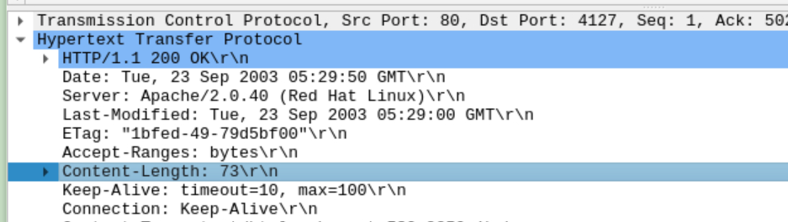

Q5.

According to Content-Type header, the data contained inside the HTTP response packet is HTML text file.

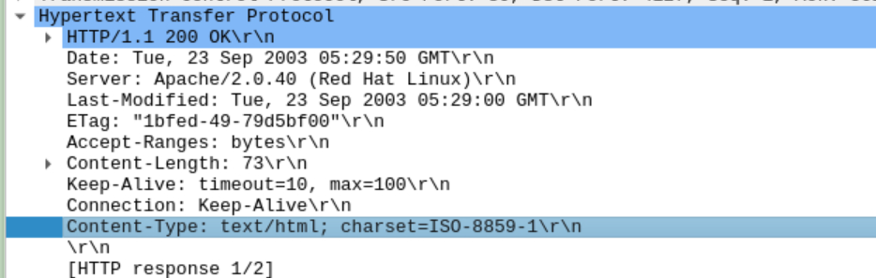

Exercise 4:

Q1.

Not seeing "IF-MODIFIED-SINCE" line in HTTP GET.

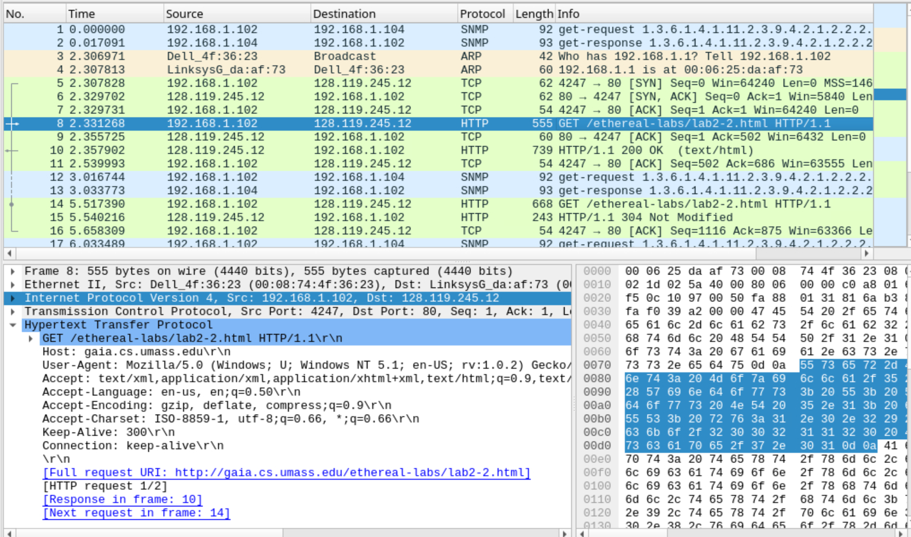

Q2.

Yes, the HTTP response from the server indicates the last time the requested file was modified, which was on Tue, 23 Sep 2003 05:35:00 GMT.

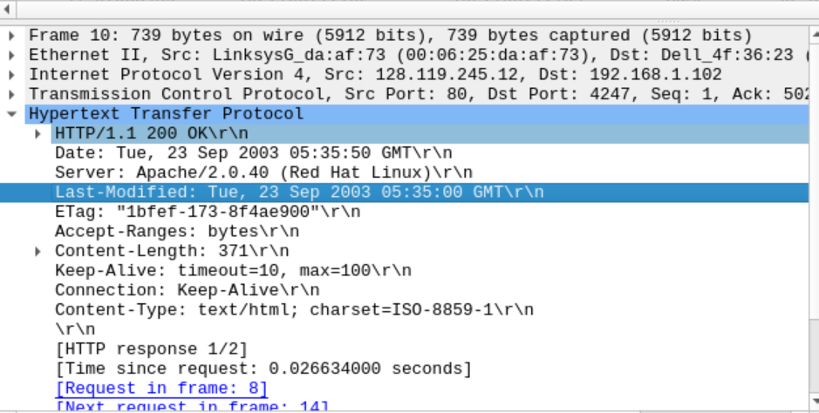

Q3.

"IF-MODIFIED-SINCE:" and "IF-NONE-MATCH" can be seen in the response. If-Modified-Since: This header field indicates the time when the client obtained the resource. The server will check whether the last modification time of the resource is later than this time. If the resource is not updated, the server will return a 304 Not Modified response. If-None-Match: This header field contains an entity tag (ETag) that identifies the resource.

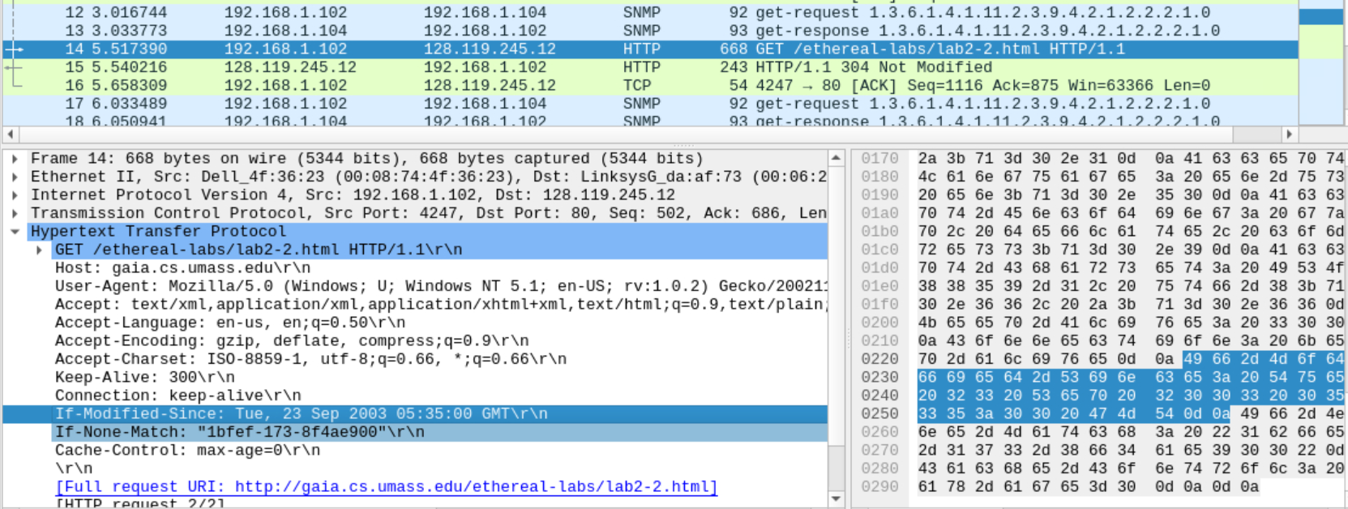

Q4.

The HTTP status code and phrase returned from the server in response to the second HTTP GET are "304" and "Not Modified".

The server does not return the contents of the file because "304 Not Modified" means that the resource the client last fetched has not been updated, which means that the version of the file stored on the proxy server can be sent to the client without losing any modifications. The client can use its local cached copy.

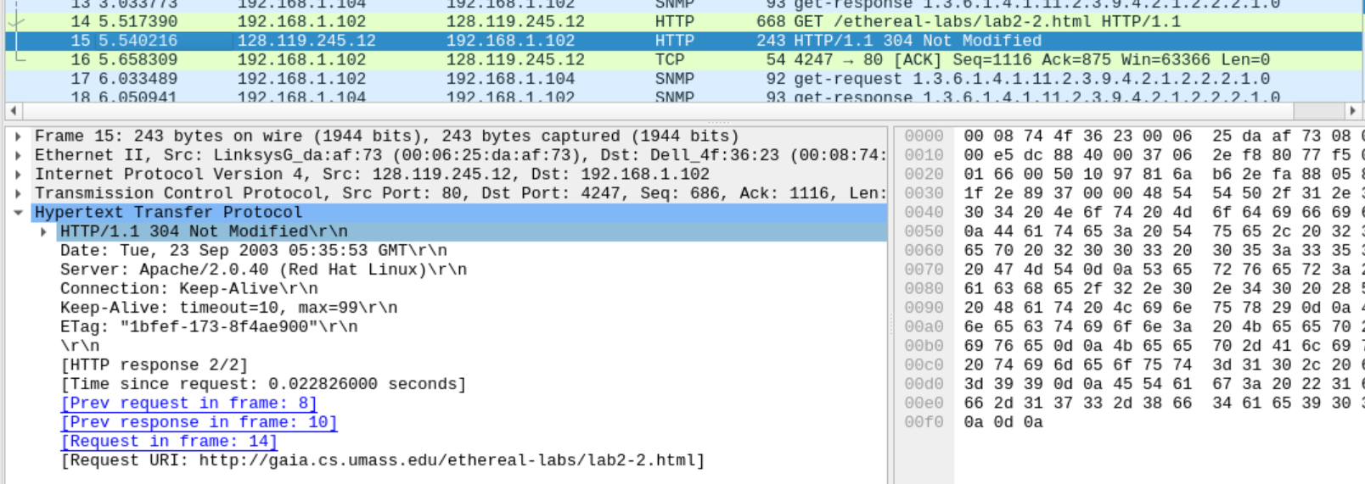

Q5.

The value of the Etag field in the second response message is 1bfef-173-8f4ae900. Etag is a field in the HTTP response header. It is a unique identifier generated by the server and is used to identify a specific version of the resource. It can guarantee the uniqueness of resources to a large extent, thereby effectively performing cache control. The second Etag value is the same as the first response.

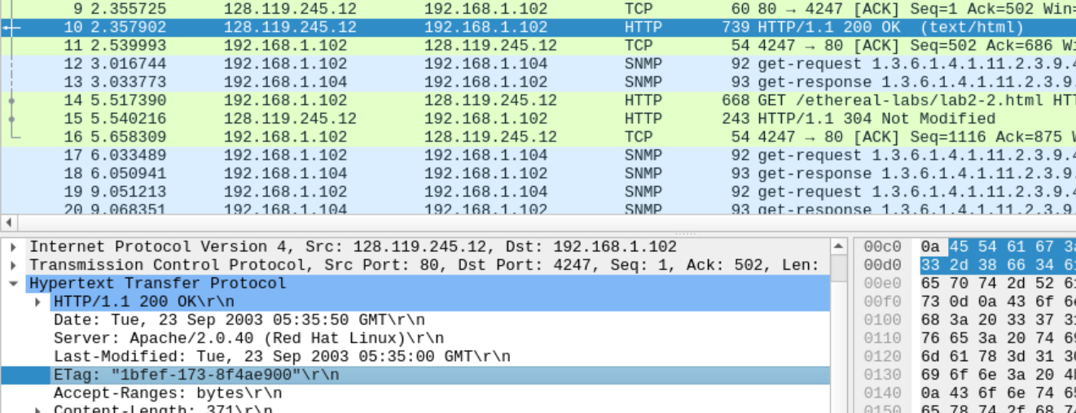

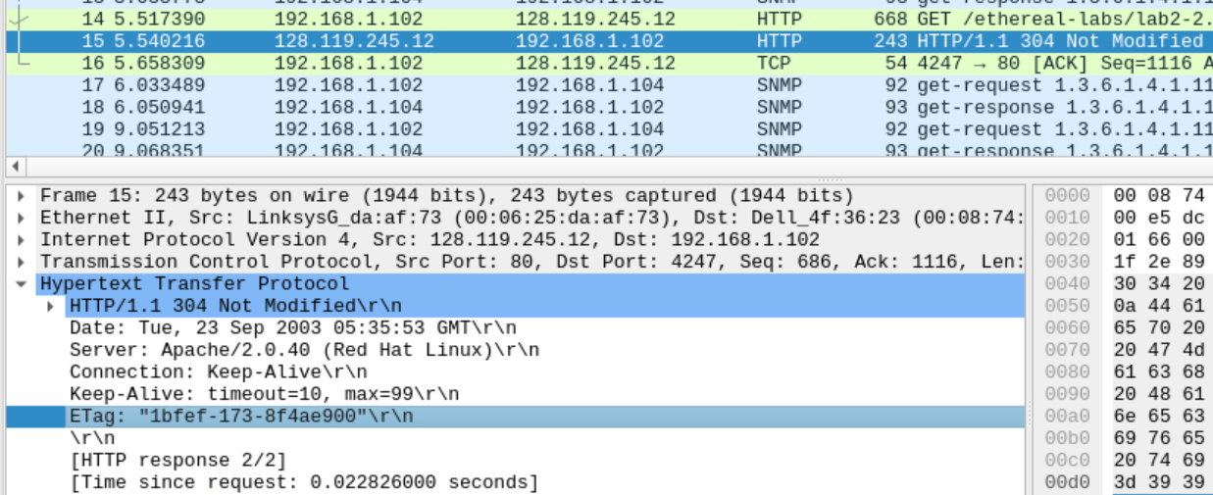

Exercise 5:

The output is as follows:

